PART 0: Opening Scene

Beginning Part 1
The fourth and final day of training has come to a close at the Grand Lodge of Absalom, heralding the end of this year’s Torchbearing. Pathfinders the world over attend this annual symposium to share their knowledge, teach each other new skills, and reinforce their connections across the Inner Sea and beyond. To celebrate the end of festivities, the lodge has hosted a grand banquet in the visiting agents’ honor. A refreshing winter breeze blows through an open window, flickering torches and sending papers scattering. The smell of freshly baked desserts fills the air while initiates clear away the remnants of the first course.

Restful Pathfinder’s Lounge Vanity = Hero’s Feast
- +1 guest or companion

15 minutes – character introductions
Have players talk about one Skill that they learned either recently or are most familiar with
- PCs become specialized in that skill for this adventure

Diplomacy (gather information) or Knowledge (local)
Based on the result of their skill check, the PCs might know more about the Torchbearing. They learn all of the information whose DC is equal to or less than the result of their check.
- 15+: The Three Masters use the event to keep an eye out for particularly talented agents that embody the Pathfinder Society ideals: Explore, Report, and Cooperate.
- 20+: At the end of the Torchbearing, the most exemplary agents are publicly recognized and given special wayfinders.
- 25+: Sometimes Pathfinder agents disappear for hours during the course of events. Rumors suggest they are brought before The Decemvirate, but no one can agree on why.

After introductions, skills, and skill checks:
As the Pathfinders conclude the dessert course, a small origami swan flutters through the room and lands on the center of the table. In moments, it unfolds itself into a crisp and creaseless piece of paper.

HANDOUT #1

Knowledge (nobility)
Based on the result of their Knowledge (nobility) check, the PCs might know more about the Blakros Family. They learn all of the information whose DC is equal to or less than the result of their checks.
- 10+: The Blakros are one of the wealthiest and most well-known merchant families from Taldor. They own a variety of businesses with interests all over the Inner Sea.
- 15+: For years, the Pathfinder Society and the Blakros family have been allies, even if only at arm’s length. Occasionally the family invites notable Pathfinders to one of its high-society affairs.
- 20+: The Blakros family has been involved with some shady organizations during its rise to power, including the Onyx Alliance and House Thrune.
Knowledge (local)
Based on the result of their Knowledge (local) checks, the PCs might know more about the Blakros Museum. They learn all of the information whose DC is equal to or less than the result of their checks.
- 10+: The Blakros Museum is located in the Wise District, owned by the Blakros family, and curated by Nigel Aldain (a former Pathfinder). It is open to the public when an exhibit is on display. Though the exterior of the building is ugly and squat, patrons marvel at how much bigger it is on the inside.
- 15+: The museum has been closed for the past several months, ramping up for a huge exhibit, “Legacy of the Shining Crusade,” opening next week.
- 20+: Rumors suggest that shadow magic makes the inside of the museum larger. A few years ago the inside changed drastically, which drew the curiosity of many in Absalom.
- 25+: Ralzeros the Overwatched was a powerful wizard who owned the building before the Blakros Family. Evidence suggests he cursed the building on his death. The number of accidents and strange events that occur there would seem to support that rumor.
Knowledge (local)
Based on the result of their Knowledge (local) checks, the PCs might know more about Nigel Aldain. They learn all of the information whose DC is equal to or less than the result of their checks.
- 10+: Though the relationship between the Society and Nigel is often strained, they remain steadfast allies. Nigel often collaborates with the Society, loaning artifacts and trading information. He has obsessively researched the Shining Crusade for the past several months.
- 15+: Nigel is a former Pathfinder who resigned after marrying Dhrami Blakros; the position of curator was part of his marriage contract.
- 20+: Nigel’s museum has suffered many mishaps since he became curator, which the Society has regularly helped clean up. Nigel still tries to distance himself from the Society and act independently, but when trouble befalls the museum, he often turns to the Society for help.
- 25+: Recently, Nigel has spent a fortune in security for the museum, particularly in magical protections from the Arcanamirium and Golemworks in Magnimar.
Skill Specialization:
Having recently trained with the three Masters of the Society, one skill is particularly fresh in your mind and body. If this is a class skill, you get a +1 circumstance bonus to it for the adventure; otherwise it becomes a class skill for the duration of the adventure.

SKILL:_______________
Skill Specialization:
Having recently trained with the three Masters of the Society, one skill is particularly fresh in your mind and body. If this is a class skill, you get a +1 circumstance bonus to it for the adventure; otherwise it becomes a class skill for the duration of the adventure.

SKILL:_______________
Skill Specialization:
Having recently trained with the three Masters of the Society, one skill is particularly fresh in your mind and body. If this is a class skill, you get a +1 circumstance bonus to it for the adventure; otherwise it becomes a class skill for the duration of the adventure.

SKILL:_______________
HEROES' FEAST
School conjuration [creation]; Level bard 6, cleric 6
Casting Time 10 minutes
Components V, S, DF
Range close (25 ft. + 5 ft./2 levels)
Effect feast for one creature/level
Duration 1 hour plus 12 hours; see text
Saving Throw none; Spell Resistance no
You bring forth a great feast, including a magnificent table, chairs, service, and food and drink. The feast takes 1 hour to consume, and the beneficial effects do not set in until this hour is over. Every creature partaking of the feast is cured of all sickness and nausea, receives the benefits of both neutralize poison and remove disease, and gains 1d8 temporary hit points + 1 point per two caster levels (maximum +10) after imbibing the nectar-like beverage that is part of the feast. The ambrosial food grants each creature that partakes a +1 morale bonus on attack rolls and Will saves and a +4 morale bonus on saving throws against poison and fear effects for 12 hours.
If the feast is interrupted for any reason, the spell is ruined and all effects of the spell are negated.
Nigel Aldain 15+:
Nigel is a former Pathfinder who resigned after marrying Dhrami Blakros; the position of curator was part of his marriage contract.
Blakros Museum 20+:
Rumors suggest that shadow magic makes the inside of the museum larger. A few years ago the inside changed drastically, which drew the curiosity of many in.
Blakros Museum 15+:
The museum has been closed for the past several months, ramping up for a huge exhibit, “Legacy of the Shining Crusade,” opening next week.
Nigel Aldain 10+:
Though the relationship between the Society and Nigel is often strained, they remain steadfast allies. Nigel often collaborates with the Society, loaning artifacts and trading information. He has obsessively researched the Shining Crusade for the past several months.
Blakros Museum 25+:
Ralzeros the Overwatched was a powerful wizard who owned the building before the Blakros Family. Evidence suggests he cursed the building on his death. The number of accidents and strange events that occur there would seem to support that.
Blakros Museum 10+:
The Blakros Museum is located in the Wise District, owned by the Blakros family, and curated by Nigel Aldain (a former Pathfinder). It is open to the public when an exhibit is on display. Though the exterior of the building is ugly and squat, patrons marvel at how much bigger it is on the inside.
Blakros Family 20+:
The Blakros family has been involved with some shady organizations during its rise to power, including the Onyx Alliance and House Thrune.
Blakros Family 15+:
For years, the Pathfinder Society and the Blakros family have been allies, even if only at arm’s length. Occasionally the family invites notable Pathfinders to one of its high-society affairs.
Blakros Family 10+:
The Blakros are one of the wealthiest and most well-known merchant families from Taldor. They own a variety of businesses with interests all over the Inner Sea.
Torchbearing 15+:
The Three Masters use the event to keep an eye out for particularly talented agents that embody the Pathfinder Society ideals: Explore, Report, and Cooperate.
Torchbearing 20+:
At the end of the Torchbearing, the most exemplary agents are publicly recognized and given special wayfinders.
Torchbearing 25+:
Sometimes Pathfinder agents disappear for hours during the course of events. Rumors suggest they are brought before The Decemvirate, but no one can agree on why.
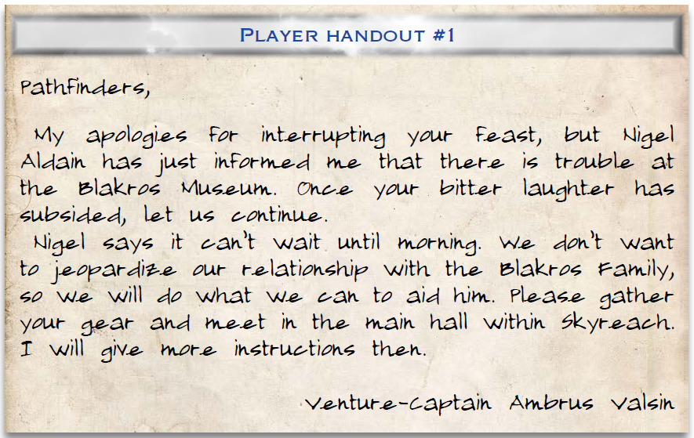
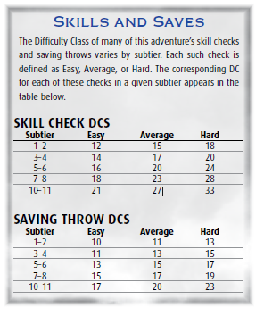
Nigel Aldain 20+:
Nigel’s museum has suffered many mishaps since he became curator, which the Society has regularly helped clean up. Nigel still tries to distance himself from the Society and act independently, but when trouble befalls the museum, he often turns to the Society for help.
Nigel Aldain 25+:
Recently, Nigel has spent a fortune in security for the museum, particularly in magical protections from the Arcanamirium and the Golemworks in Magnimar.

