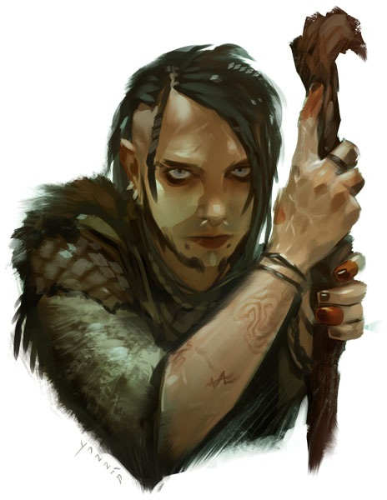
Osprey
Pathfinder Agent
with ties to the Decemvirate
True Neutral
Human Male Druid 11

The druid Osprey is a member of the Pathfinder Society, although he tends to work outside of the organization's standard hierarchical framework. He gets his name from his habit of wildshaping into dark-eyed raptors. The enigmatic Pathfinder is rumored to be writing a secret report that he guards jealously; only bits of it have been fed to the Decemvirate. Osprey is known to be an expert on the Kortos Consortium and their activities in Diobel and Absalom. Osprey appears to be in his late 40's, with dark hair and a shadow of a beard. His light eyes are piercing, perhaps even haunting.
Scenarios Featuring Osprey | Characters Who Met Osprey
2 – The Hydra’s Fang Incident
16 – To Scale the Dragon
24 – Decline of Glory
34 – Encounter at the Drowning Stones
40 – Hall of Drunken Heroes
2-Ex – Year of the Shadow Lodge
2-12 – Below the Silver Tarn
2-14 – The Cavern of Screams

