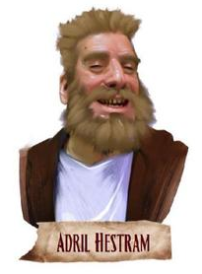
Adril
Hestram
Pathfinder Society
Venture-Captain
Neutral Good
Human Male Fighter 9
Hestram is a bear of a man, standing well over six feet tall. While his large girth might be deceiving, his bulk is mostly muscle, and he can frequently be found sparring with other members of the Society to further develop his strength. Other notable features include his nearly toothless grin and long, scraggly beard.

Scenarios Featuring Adril Hestram | Characters Who Met Adril Hestram
1 – Silent Tide
3 – Murder on the Silken Caravan
4 – The Frozen Fingers of Midnight
5 – Mists of Mwangi
17 – Perils of the Pirate Pact
20 – King Xeros of Old Azlant
22 – Fingerprints of the Fiend
26 – Lost at Bitter End
31 – Sniper in the Deep
35 – Voice in the Void
38 – No Plunder, No Pay

