Reefclaw (Knowledge: Dungeoneering or Nature) DC 11
Blood-red spines run the length of this frightening creature, which resembles a lobster in the front and an eel in the back. Reefclaws are vicious predators. They possess greater intelligence than animals, but rely mainly on their strength and instincts to survive. They hunt fish, giant crabs, dolphins, and even land-dwelling creatures that come within a hundred paces of the water.

In addition to the raw power of their crushing claws, the barbed appendages exude a dangerous neurotoxin that saps their strength from their prey. [Poison (Ex) Claw—injury; save Fort DC 13; frequency 1/round for 4 rounds; effect 1d2 Str; cure 1 save.]

Reefclaw (Knowledge: Dungeoneering or Nature) DC 16
Reefclaws are resistant to the frigid depths of the ocean, and have been known to shrug off cold attacks from lesser opponents. [Cold resistance 5]

Reefclaw (Knowledge: Dungeoneering or Nature) DC 21
These creatures tend to die hard, fighting well past the point when a different creature would have succumbed to its wounds. Brave folk who have faced the monsters report that when even mortally injured they are still deadly, in their death throes they try and sweep anything next to them into a final embrace. [Ferocity, Death frenzy]

Bunyip (Knowledge: Arcana) DC 13
A disturbing combination of shark and seal, this brown-furred creature has a wide mouth filled with razor-sharp teeth. The bunyip is a fierce and avid hunter, possessing a primal ruthlessness that seems almost evil in its rapacity. A bunyip typically inhabits large freshwater inlets or sheltered coastal sea caves where food is plentiful—the bunyip is equally at home in fresh or salt water. Their teeth are serrated and can cause wounds that are difficult to staunch. [Improved Critical (Bite), Bleed]

Bunyip (Knowledge: Arcana) DC 18
They are quite territorial beasties. Usually Bunyips warn away intruders with their supernaturally loud and horrifying roar, which can end a fight before it begins. [Roar (panicked)]

Bunyip (Knowledge: Arcana) DC 23
These creatures have exceptional senses. Like sharks they can smell blood in the water from great distances, and the taste of it puts them into a frenzy. [Blood Rage]
Bunyip (Knowledge: Arcana) DC 28
Although primarily aquatic animals, Bunyips breathe air and can remain out of water for days at a time if needed. They are slow on land, however, and never venture too far from their natural home. [Amphibious]

Basilisk (Knowledge: Arcana) DC 15
This squat, reptilian monster has eight legs, bony spurs jutting from its back, and eyes that glow with pale green fire. Don’t look at it directly! Basilisks are magical beasts that can turn living creatures to stone with their gaze. They are no more intelligent than normal animals, and are also quite lazy. Despite having eight legs they are rather slow and clumsy. [Gaze (turn to stone)]

Basilisk (Knowledge: Arcana) DC 20
There’s hope for the fallen. A creature turned to stone by a basilisk may be returned to life if their petrified form is covered in the blood of a recently killed basilisk, no matter how long ago they were initially turned. It usually takes several pints of the blood to accomplish this. Once the blood congeals it loses its magic. This takes about 50-60 minutes. [Gaze (antidote)]

Basilisk (Knowledge: Arcana) DC 25
Basilisks are heavily reliant on their petrifying gaze to protect them from enemies. In fact, their teeth are blunt, designed for crushing and grinding up stone which is their primary diet. Their jaws are still powerful, however, and they are deft at fighting in the dark. [Blind Fight]

Tiefling (Knowledge: Local or Planes) DC 6
These lanky men sneer as they draw their blades. Tiny horns, oily skin and a barbed tail reveal that they are something more than human. Tieflings are humans with demonic, devilish, or other evil outsider blood in their ancestry.

Tiefling (Knowledge: Local or Planes) DC 11
Tieflings are able to create supernatural darkness once a day, which blinds any creature without darkvision. Naturally, tieflings see in this darkness without difficulty. [Darkness, Darkvision]

Tiefling (Knowledge: Local or Planes) DC 16
They have inherited some of the energy resistances of their ancestors. Tieflings are able to shrug off minor injuries from sources of fire, electricity and cold. [Fiendish Resistances]
Kyton (Knowledge: Planes) DC 16
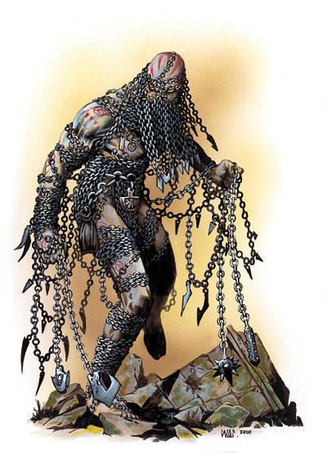
Wickedly barbed chains adorn this lean figure, and gaps in the bindings reveal deathly pale flesh etched with jagged scars. Often classified among the ranks of the infernal and called chain devils by the uninitiated, the sadomasochistic kytons are not true devils. Many suggest that kytons were natives of Hell who existed there before the advent of devilkind, while others hypothesize they were later brought to the plane by some sadistic power. Regardless of their origins, kytons roam the planes in their lust to cause and receive suffering, seeking pain through violent abductions and sadistic debauches. Kytons are supernatural masters of the chain, and can use them to hideous effect. They can even control chains they aren’t even in contact with, just using their minds. Even mundane chains sprout barbs and razor edges in their presence. [Dancing Chains]

Kyton (Knowledge: Planes) DC 21
Kytons have accelerated healing and can recover in minutes from wounds that would kill the doughtiest fighter. Good-aligned spells and weapons as well as silver weapons can interrupt the process, and send them back to the Hells whence they came. [DR/Silver or Good, Regeneration]

Kyton (Knowledge: Planes) DC 26
They are resistant to spells, as well as immune to cold. [Spell Resistance, Immunities]

Kyton (Knowledge: Planes) DC 31
Those who meet the gaze of a kyton may feel their courage melt away in the face of such a wicked and inhuman opponent. [Unnerving Gaze]

Stone Guardian Golem (Knowledge: Arcana) DC 14
An elaborate rune-carved statue appears to have been carved from a single block of stone, exhibiting aspects of a serpent’s body, a woman’s torso, six wings, and a Sihedron rune in place of a head. With a rhythmic grinding noise, the statue slides itself off its base and across the floor just like a snake, its arms raised in a menacing manner.
This is a construct known as a stone guardian golem. It is not a true golem, as it lacks spell immunity. [Construct Traits]

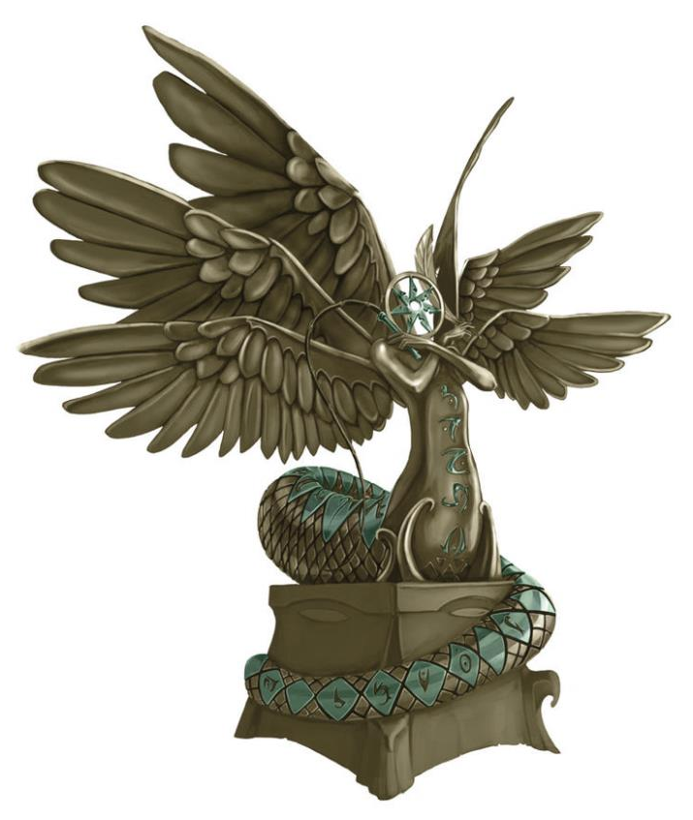
Stone Guardian Golem (Knowledge: Arcana) DC 19
Although not immune to spells, stone guardian golems are resistant to minor damage from cold, fire and electrical attacks. [Energy Resistance]

Stone Guardian Golem (Knowledge: Arcana) DC 24
These statues are ever-vigilant watchers, even invisible intrudes can’t escape their notice. [See Invisibility]

Stone Guardian Golem (Knowledge: Arcana) DC 29
A stone guardian is linked to a magic ring. The construct will never attack any creature that wears this ring, nor any creatures within 10 feet of the ring wearer, unless one of those creatures attacks the guardian first. [Ring Link]

Ebon Acolytus (Knowledge: Arcana) DC 17
An elaborate rune-carved statue appears to have been carved from a single block of stone, exhibiting aspects of a serpent’s body, a woman’s torso, six wings, and a Sihedron rune in place of a head. With a rhythmic grinding noise, the statue slides itself off its base and across the floor just like a snake, its arms raised in a menacing manner. In its hand it carries a stone wavy bladed dagger, crusted over with old blood. Dedicated to dark gods, fiends hungry for the souls of innocents, and even more monstrous beings, ebon acolyti—sometimes called altar golems—are terrifying constructs, for they are not designed merely to kill, but to aid in the ever bloody work required in the service of foul divinities. Carved from a single block of stone or other sturdy material, these constructs resemble towering statues, crafted to appear as servants of specific deities and often etched with icons sacred to their worship.

Ebon Acolytus (Knowledge: Arcana) DC 22
This construct’s method of killing is to seize victims, force them to the ground and open their throats up.
If the target is killed by this attack, its soul is sent straight to the plane of the being to which the altar is dedicated, regardless of alignment, and cannot be raised from the dead except by a cleric sworn to the same deity or by a miracle or wish spell. [Prostration, Sacrifice]

